Installing SQL Server 2012 for All Orders
Begin by download the SQL Server 2012 installation file from one of the two links below
- 32 Bit - http://numbercruncher.com/download/sql2012/SQLEXPRWT_x86_ENU.exe
- 64 Bit - http://numbercruncher.com/download/sql2012/SQLEXPRWT_x64_ENU.exe

Find the executable file after the download is complete and double click it to begin the installation.
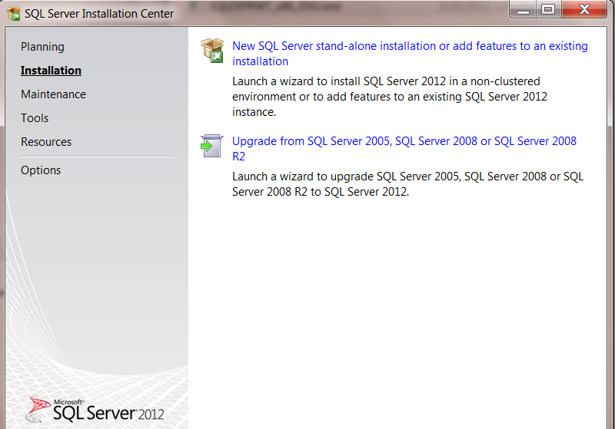

Wait for the files to finish being extracted and a screen called the SQL Server Installation Center will pop up.

Click the link labeled New SQL Server stand-alone installation or add features to an existing installation.
A screen will pop up to let you know that information is being processed.
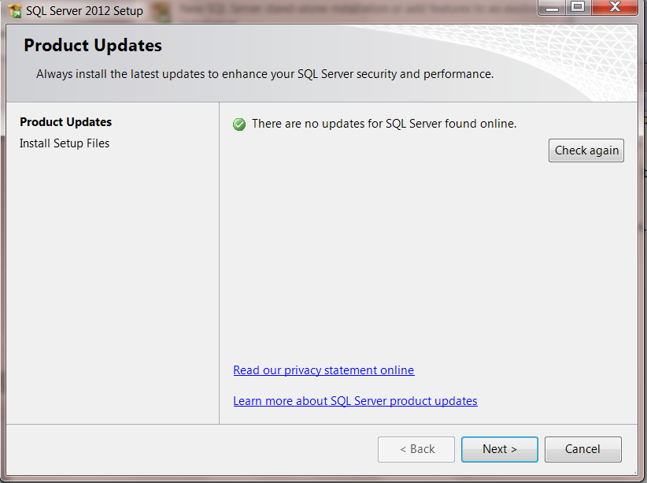

You might be prompted to check for updates or if updates are found to install them. This is optional and can be skipped.

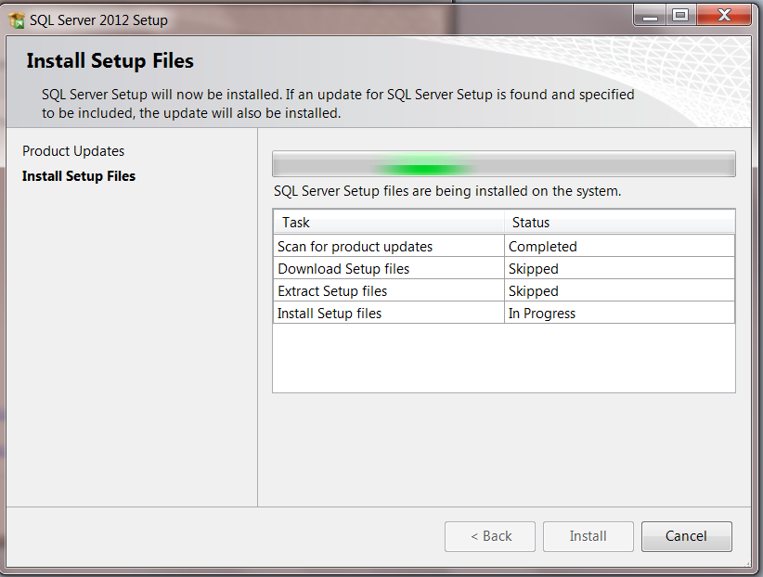

Next the installer may install some setup files.

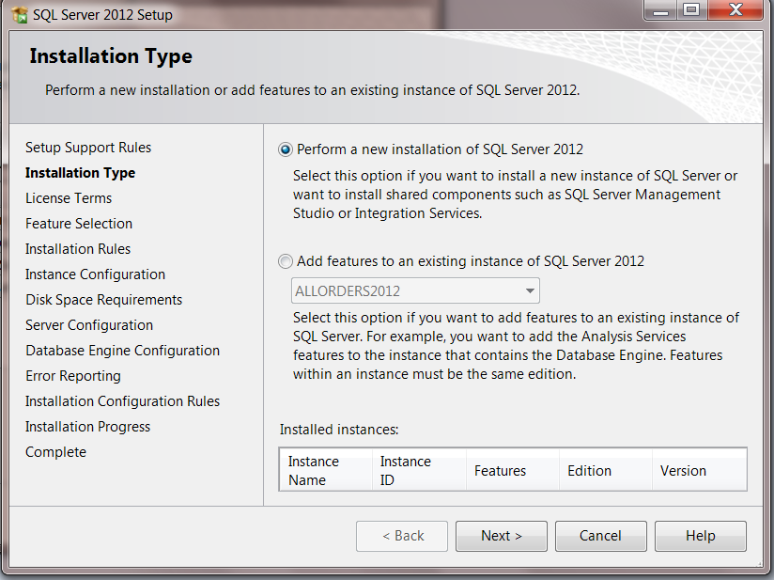

If you are presented with a screen asking you what type of installation you want to perform be sure to select a new installation.

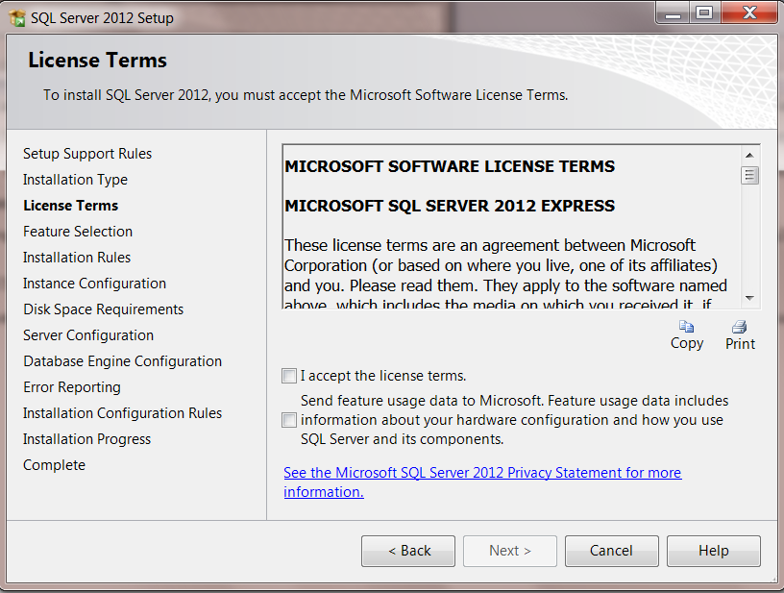
Accept the terms.

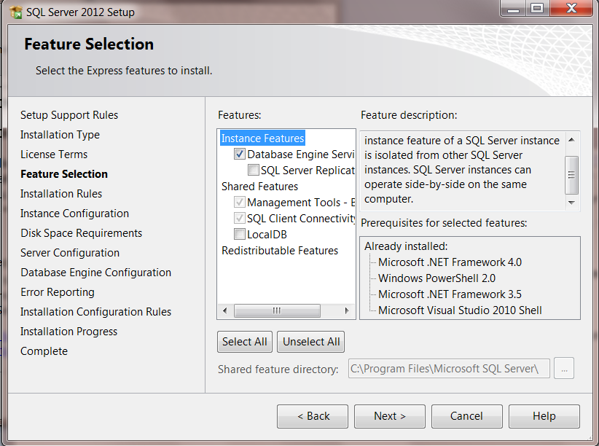

The only features that must be checked are the Database Engine Services and Management Tools.

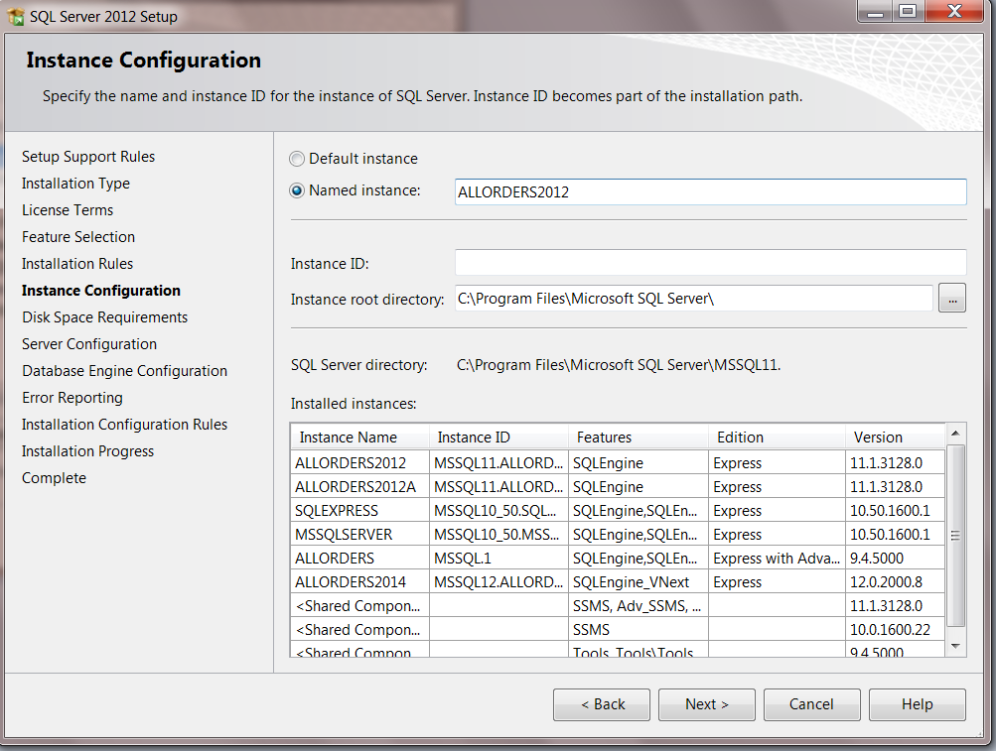

Next you will be asked to name your installation of SQL Server. Name it ALLORDERS2012 with all caps.

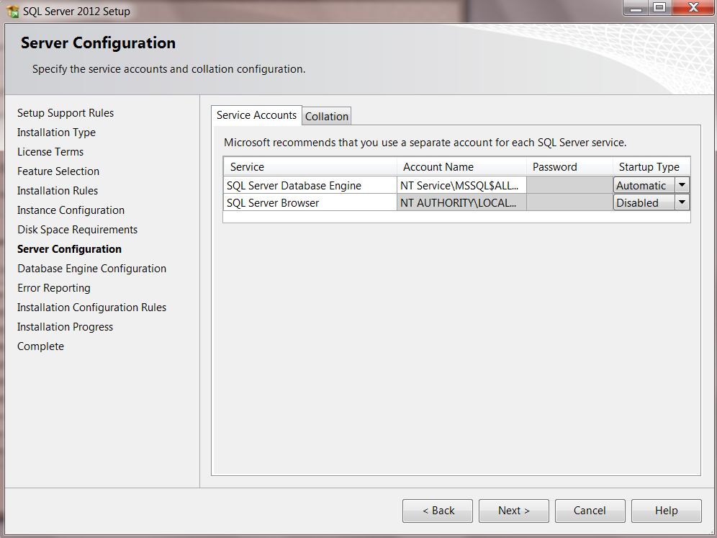

Now you will be asked to select the local Windows user that SQL Server will run under. Typically this can be left alone with whatever is already filled in.

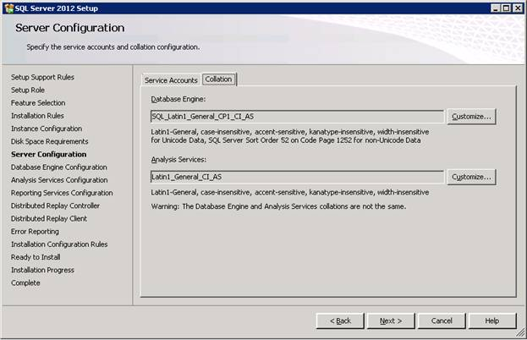
Be sure to click on the Collation tab, especially if this install is happening outside the United States, to confirm the correct collation is set for the Database Engine. It should be SQL_Latin1_General_CP1_CI_AS.

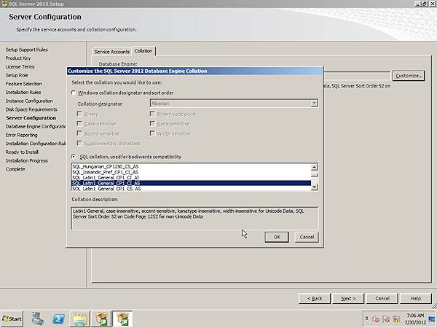
You may need to click the customize button to select it from a list of optional collations.

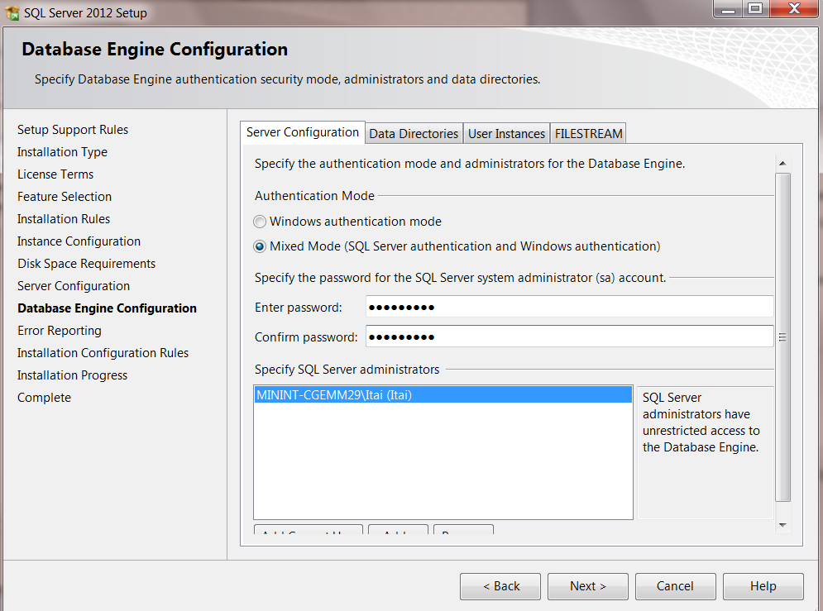

Select Mixed Mode for the Authentication Mode and enter the password of Sysadmin1 and confirm it. Typically everything else can be left alone and you can move to the next step.

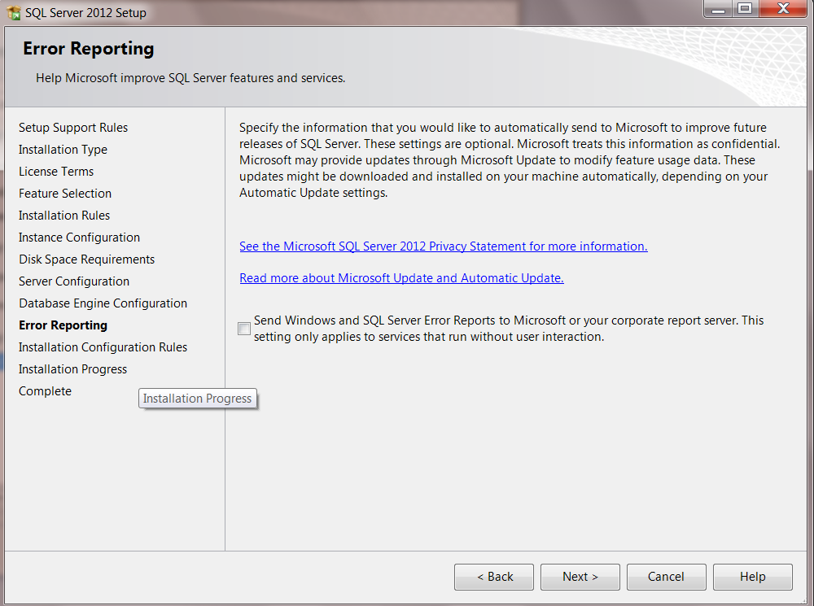

Click next after reading the information on the error reporting screen.

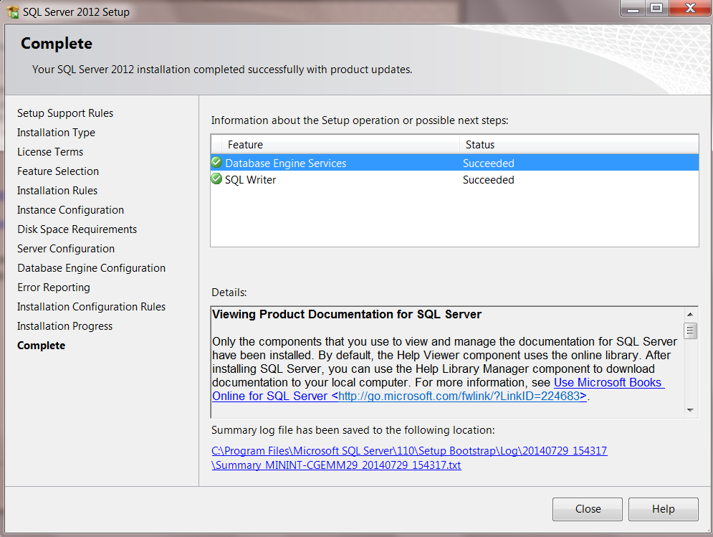

Now the installation will begin. If you get errors and are unsure of how to resolve them please contact NumberCruncher support at support@numbercruncher.com. Any screenshots you can take of the error are always helpful on resolving the issue as quickly as possible. If the installation completes successfully you are now ready to install and open the All Orders client and create a new company file and database now that SQL Server has been installed.

